[ZANG] - [Chuanjie]

Student ID: 699382953

[chuanjiezang@gmail.com](mailto:chuanjiezang@gmail.com)

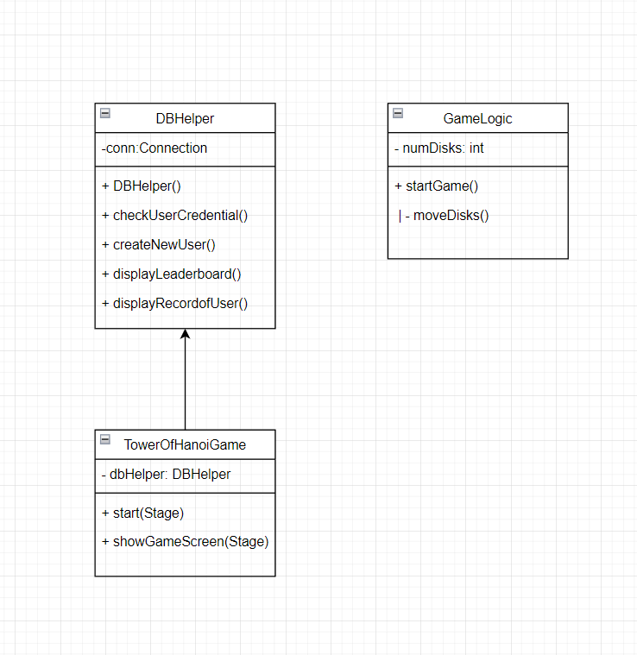

Flow step:

Launch the application:

Opens the application and displays the login screen.

User logs in or registers:

User enters user name and password.

The user can choose to log in or register.

Validate User:

When logging in, verify user credentials.

When registering, create a new user.

Display game interface:

After the user has successfully logged in, the main game interface is displayed.

Start Game:

The user clicks the “Start Game” button and the game logic starts.

Translated with DeepL.com (free version)

Complete the creation of basic package and classes:

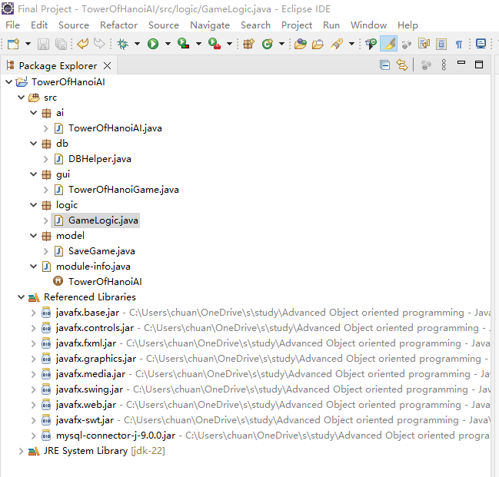

Finish all the code;

Create MySQL, use MySQL Workbench, we need create lib ‘hanoi’ and table ‘users:

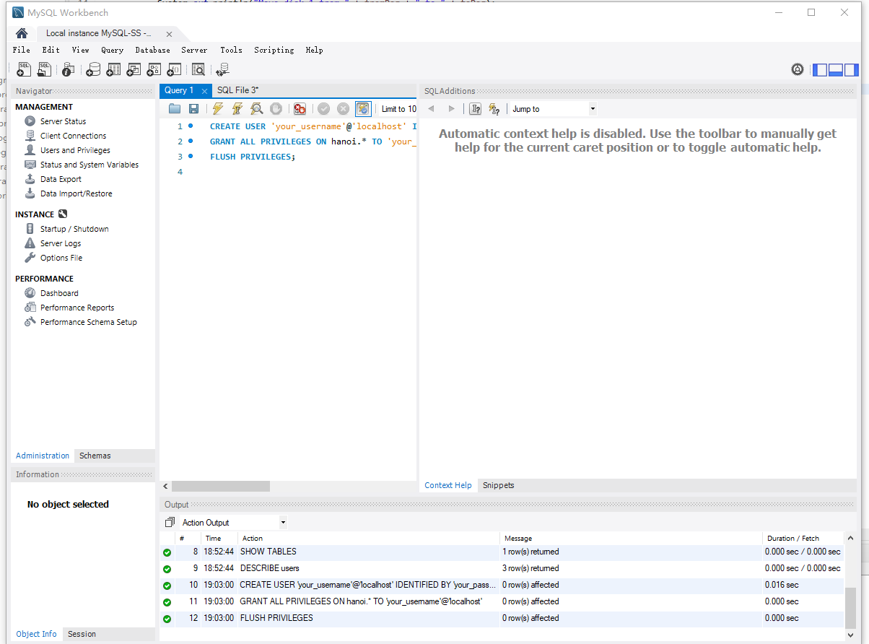

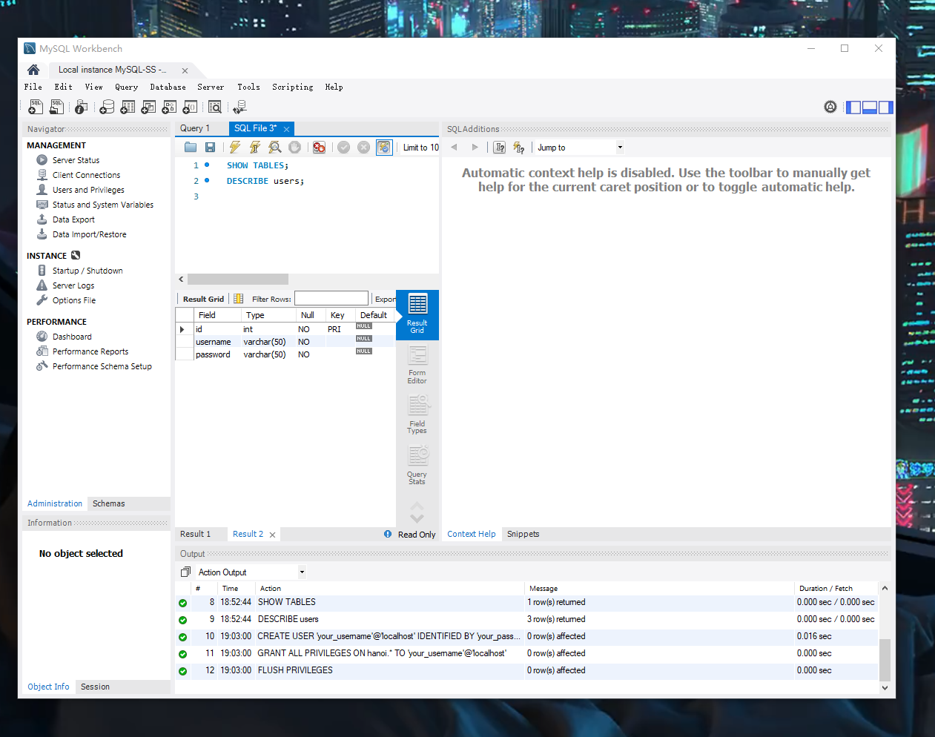

Change code ‘DBHelper’ to link MySQL, i use name:your_username and password:your_password;

Run:

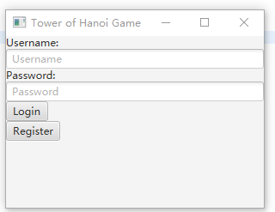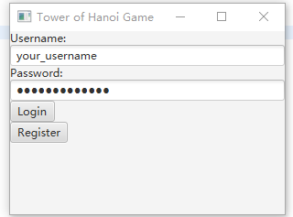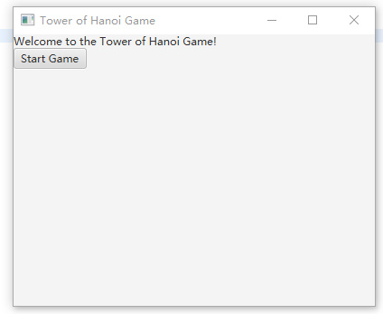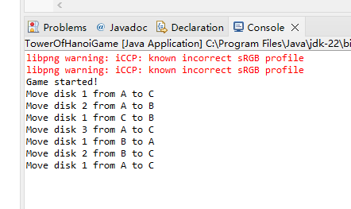

Export the SQL lib:

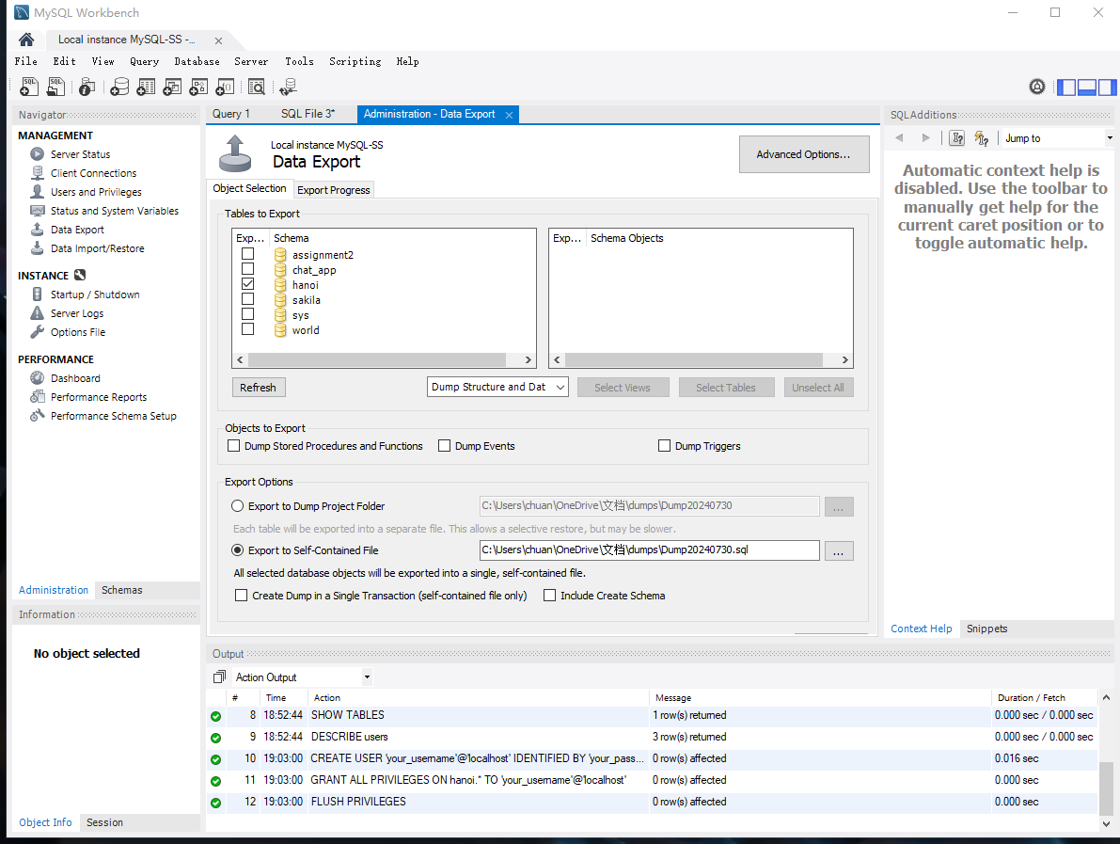

SQL name: hanoi_backup.sql

